# Relational Databases with MySQL Week 12 Coding Assignment

**Points possible:** 70

|  |  |  |
| --- | --- | --- |
| **Category** | **Criteria** | **% of Grade** |
| **Functionality** | Does the code work? | 25 |
| **Organization** | Is the code clean and organized? Proper use of white space, syntax, and consistency are utilized. Names and comments are concise and clear. | 25 |
| **Creativity** | Student solved the problems presented in the assignment using creativity and out of the box thinking. | 25 |
| **Completeness** | All requirements of the assignment are complete. | 25 |

**Screenshots of Code:**

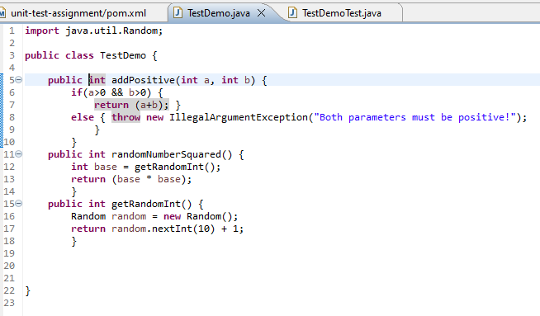

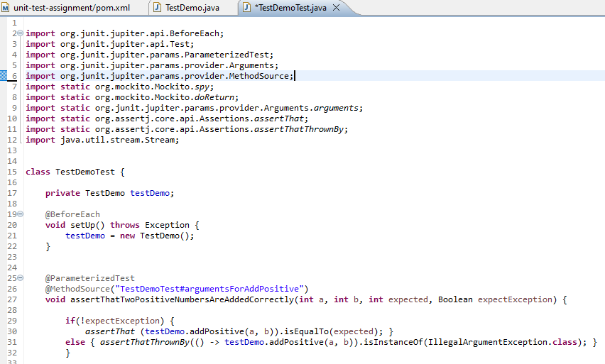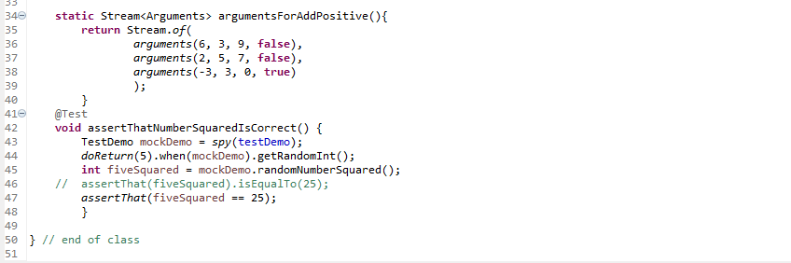

**Screenshots of Running Application:**

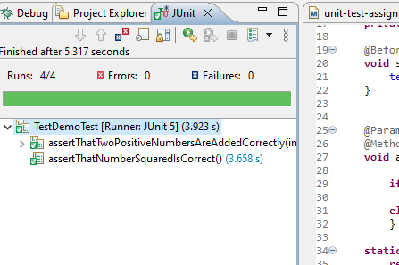

**URL to GitHub Repository:**

[**nichspragg/Week-12-JUnit-Testing (github.com)**](https://github.com/nichspragg/Week-12-JUnit-Testing)

**https://github.com/nichspragg/Week-12-JUnit-Testing**